Project M: Markel First ProposalEngine
Business Requirements and Acceptance Criteria

1. Purpose

2. What we produce and when
 | Initial release | Subsequent release (backlog)
What we produce | EPICs: capability descriptions, interaction point, inputs/outputs, acceptance criteria, out of scope, open dependencies | User stories: finer-grained requirements by feature, with individual definitions of done and ready
Purpose | Protect scope. Give the client something to review and approve before build begins. | Drive the build. Give the engineering team implementation-ready requirements sprint by sprint.
Sign-off | Client reviews and approves EPICs before Phase 2 begins. Changes after sign-off follow the SOW change request process. | Client reviews and approves user stories on a rolling basis, ahead of build work. The goal is to define and approve all user stories as early as possible in Phase 2, not to tie sign-off to sprint boundaries.

3. EPIC set for the ProposalEngine
The EPIC’s to be completed and approved. The initial proposal engine will cover General Liability (GL) for the following set of class codes and industries:
Contractors

- 91582 - Contractors - subcontracted work - in connection with building construction, reconstruction, repair or erection - apartment or office buildings over four stories
- 91584 - Contractors - subcontracted work - in connection with construction, reconstruction, repair or erection of buildings - for industrial use
- 91585 - Contractors - subcontracted work - in connection with construction, reconstruction, repair or erection of buildings - Not Otherwise Classified
- 98678 - Roofing - residential - three stories and under
- 98677 - Roofing - commercial or residential over three stories
- 91342 - Carpentry - Not Otherwise Classified
- 91341 - Carpentry – interior
- 91560 - Concrete Construction
- 98449 - Plastering or Stucco Work
- 94381 - Fire Suppression Systems - installation, servicing or repair
- 92101 - Drilling - Not Otherwise Classified
- 91577 - Conduit Construction for Cables or Wires
- 99986 - Wrecking - buildings or structures - Not Otherwise Classified
- 97655 - Metal Erection - structural - Not Otherwise Classified
- 97653 - Metal Erection - nonstructural - Not Otherwise Classified
- 97222 - Machinery or Equipment - industrial - installation, servicing or repair
- 97223 - Machinery or Equipment - installation, servicing or repair - Not Otherwise Classified
- 95647 - Heating or Combined Heating and Air Conditioning Systems or Equipment - dealers or distributors and installation, servicing or repair - no liquefied petroleum gas (LPG) equipment sales or work
- 98483 - Plumbing - residential or domestic
- 98482 - Plumbing - commercial and industrial
- 97047 - Landscape Gardening
- 99507 - Swimming Pools - installation, servicing, or repair - below ground
- 98304 - Painting - exterior - buildings or structures - three stories or less in height - Not Otherwise Classified
- 98305 - Painting - interior buildings or structures
- 92478 - Electrical Work - within buildings
- 91746 - Door, Window or Assembled Millwork - installation metal
- 99969 - Welding or Cutting

OL&T

- 45190 - Hotels and Motels - with pools or beaches - less than four stories
- 45192 - Hotels and Motels - without pools or beaches - less than four stories
- 45191 - Hotels and Motels - with pools or beaches - four stories or more
- 45193 - Hotels and Motels - without pools or beaches - four stories or more
- 61212 - Buildings or Premises - bank or office - mercantile or manufacturing (Lessor's risk only)
- 48925 - Swimming Pools - Not Otherwise Classified
- 47051 - Real Estate Development Property
- 68706 - Warehouses - private (For-Profit)
- 68702 - Warehouses - occupied by multiple interests (lessor's risk only)
- 13673 - Grocery Stores (excluding Supermarkets with receipts in excess of $500,000 and area in excess of 3,000 sq. feet)
- 18501 - Supermarkets - with receipts in excess of $500,000 and area in excess of 3,000 square feet
- 44315 - Health or Exercise Facilities - commercially operated
- 12374 - Drugstores - no table or counter service for beverage or food
- 67635 - Shopping Centers - excluding indoor malls - buildings or premises not occupied by the insured (lessor's risk only)
- 46603 - Parking - public - not open air
- 46604 - Parking - public - open air
- 46606 - Parking - public - shopping centers - maintained by lessee - (lessor's risk only)
- 46607 - Parking - public - shopping centers - maintained by the insured - (lessor's risk only)
- 41677 - Consultants - Not Otherwise Classified
- 68606 - Vacant Buildings - not factories (For-Profit)
- 68607 - Vacant Buildings - not factories (Not-For-Profit)
- 68604 - Vacant Buildings – factories
- 49451 - Vacant Land - Other than Not-For-Profit
- 49452 - Vacant Land - Not-For-Profit onl

Habitational
- 60010 - Apartment Buildings
- 62003 - Condominiums - residential - (association risk only)
- 68500 - Townhouse Associations (association risk only)
- 46202 - Mobile Home Parks or Courts
- 10331 - Campgrounds (For-Profit)
- 61000 - Boarding or Rooming Houses
- 63010 - Dwellings - one-family (lessor's risk only
- 48924 – Swimming Pools – Commercially Operated
- 48925 – Swimming Pools – Not Otherwise Classified
- 46671 – Parks and Playgrounds
- 46622 – Parking – Private
- 46603 – Parking – Public – note open air
- 46604 – Parking – Public – Open air
- 46606 – Parking – Public – Shopping centers – maintained by lessee – (LRO only)
- 46607 – parking – public – shopping centers – maintained by insured – LRO only
- 48727 – streets, roads, highways or bridges – existence and maintenance hazard only
- 41667 – clubs – civic, service or social – having buildings (for profit)
- 41668 – clubs - civic, service or social – having buildings (non-for-profit)
- 10105 – boat storage and moorage
- 14731 – laundries and dry cleaners – self service

The following non-GL add-ins will be applied:
- Inland Marine endorsement to the GL primary form
- Commercial Excess over the GL primary (follows form and exact terms with increased the limits)

EPIC ID | Stages | Name | Description
EPIC-10 | PREPARE-TO-UW | Submission intakes prepare for analysis | Ingest unstructured submission (e.g., emails describing risk, ACORD forms, supplemental questionnaires, and loss runs) to confirm necessary data available to underwrite, rate, and construct and initial proposal. Process should block until complete and 10min SLA only starts when the complete set of data is available for processing.
EPIC-20 | PREPARE-TO-UW | Routing and human in the loop handling for submission intakes prepare for UW analysis and rating | Human in the loop corresponding with brokers to collect any missing submission information or react to clearance issues during the submission intake process (e.g., failed to pass OFAC check, broker of record issues, etc.)
EPIC-30 | PREPARE-TO-UW | Automatically collect 3rd party data necessary to underwrite and rate | Collect any 3rd party data related to the risk for underwriting and pricing purposes inclusive of crime score, D&B, OSHA/EPA/court data, credit report, and website scraping/analysis. Full list for general liability will be described.
Stage gate - before automated UW occurs
EPIC-40 | INITIAL-UNDERWRITE | Automatically prepare initial quotes | Prepare at least initial quotes based on submission data and 3rd party data collected. These may include:  Minimal coverage with maximum exclusions  Target premium optimized with exclusions, terms (e.g., limits, agg limits, sub limits, deductibles, etc.), and suggested coverages and exclusions forms.  Advised and balanced coverage price optimized for protecting insured balancing cost and coverage.  A la Carte pricing with additional policy features associated with price (e.g., simplified add’l insured, add pollution coverage cost).  Initial pricing, forms, and subjectivities will be on the generated proposals.
Stage gate – Post automated UW – Human in the loop
EPIC-50 | ROUTE-TO- UNDERWITER | Underwriter routing and interface to pull and finalize submission | When automated UW is complete a human need to start the review process and finalize sending out the submission.
EPIC-60 | HL-UNDERWRITE | Submission human in the loop review and modify user interface and data model | Provide user interface and data model to store to enable review and modification of the submissions and high-level control of proposal creation, copy, or identify differences between proposals
EPIC-61 | HL-UNDERWRITE | Proposal human in the loop review and modify user interface and data model | Provide user interface and data model to store to enable review and modification of the proposals.
EPIC-62 | HL-UNDERWRITE | Proposal comparison view | Describe the views and capabilities related to viewing two proposals and their differences
EPIC-70 | BIND-ISSUE | Bind and issue policy with E2 integration | Finalize collection of subjectivities and all steps necessary to bind and issue the policy. Send selected proposal to e2 to start bind and issue process.  (Target phase 1 if possible)
Application Support Services
EPIC-80 | UW-SUPPORT | Rating and pricing integration | Interface protocol and data exchange formats to call HX rating with modifiers to retrieve both technical rate and develop market pricing which will be provided by the HX engine.
EPIC-90 | UW-SUPPORT | Form document selection integration | Integrations with the FAST document management system to get the initial form list for a given code, the selection. Figure out where forms required fields to be filled in.
EPIC-100 | UW-SUPPORT | Quote packet generation | Provide the quote proposal and summary information sent to brokers and append form specimens.
EPIC-110 | ALL STAGES | Document storage integration with ImageRight and Cytora | Access and store documents via ImageRight. This inclusive of initial submission documents and persisting any proposal PDFs generated.
EPIC-120 | ALL STAGES | Document processing and intelligent extraction | Enable document extraction and vectorization for advanced AI based analytics of documents.
EPIC-130 | ALL STAGES | AI model rules and underwriting inference engine | This is the collective AI models and engines that will build out the forms and pricing based in UW inputs, 3rd party data and calls to the forms and rating/pricing integrations.
EPIC-140 | ALL STAGES | Rule viewer interface which may enable modification commonly changed parameters | Create UI Administration that drive syncing with administration information, view of rules where configurable, and light modification ability. (e.g., fees by state, authority level amounts, etc.)
EPIC-150 | ALL STAGES | User authentication, authorization, and authority limits | Users SSO and sign-on, group setting, authorization levels, and authority limits.
EPIC-160 | ALL STAGES | Audit, versioning + traceability | Log all submission inputs, scoring outputs, UW overrides, and model/prompt versions with full audit trail and quote versioning

4. EPIC Details

Submission intakes prepare for analysis (EPIC-10, PREPARE-TO-UW)

Description

Ingest unstructured submission (e.g., emails describing risk, ACORD forms, supplemental questionnaires, and loss runs) to confirm necessary data available to underwrite, rate, and construct an initial proposal. The process should block until complete, and the 10-minute SLA starts only when the complete set of data is available for processing.

CURRENTLY PLANNED TO BE COMPLETED BY CYTORA: Agreed to determine if this is in scope and needs to be documented and defined by 4/13/2026 (which is after 3 weeks of the project start).

Interaction points

TBD

Key inputs

TBD

Key outputs

TBD

Acceptance criteria

TBD

Out of scope

TBD

Routing and human in the loop handling for submission intakes, prepare for UW analysis and rating (EPIC-20, PREPARE-TO-UW)

Description

Human in the loop corresponding with brokers to collect any missing submission information or react to clearance issues during the submission intake process (e.g., failed to pass OFAC check, broker of record issues, etc.)

CURRENTLY PLANNED TO BE COMPLETED BY CYTORA: Agreed to determine if this is in scope and needs to be documented and defined by 4/13/2026 (which is after 3 weeks of the project start).

Interaction points

TBD

Key inputs

TBD

Key outputs

TBD

Acceptance criteria

TBD

Out of scope

TBD

Automatically collect 3rd party data necessary to underwrite and rate (EPIC-30, PREPARE-TO-UW)

Description

Collect any 3rd party data related to the risk for underwriting and pricing purposes, including crime score, D&B, OSHA/EPA/court data, credit report, and website scraping/analysis.

Through the initial submission, an automated call will be used to collect the following information for use by the UW:

Website scraping/analysis: Use off-the-shelf web scraping tools to crawl the website, identifying the business's activities and services, and potential underwriting risk indicators.

Cap Index: Pull crime score report used by UW to evaluate the risk

Company data owned by Markel: Leverages existing Markel sources of data for the entities:

Credit report from Expedia

OSHA/EPA/court data public record search

Dunn & Bradstreet company overview

Interaction points

This data will be pulled, associated with the submission record, and stored for future reference. For each integration, a blob will be retrieved and stored in the DB. A summery

Key inputs

TBD

Key outputs

TBD

Acceptance criteria

TBD

Out of scope

TBD

Automatically prepare initial quotes (EPIC-40, INITIAL-UNDERWRITE)

Description

Prepare at least initial quotes based on submission data and 3rd party data collected. These may include:

Minimal coverage with maximum exclusion: The “minimum to get on a job site.”

Target premium: Optimized with exclusions, terms (e.g., limits, agg limits, sub limits, deductibles, etc.), and suggested coverages and exclusions forms.

Advised and balanced coverage price: Optimized for protecting insured balancing cost and coverage.

A la Carte: pricing with additional policy features associated with price (e.g., simplified add’l insured, add pollution coverage cost)

Initial pricing, forms, and subjectivities will be on the generated proposals.

Interaction points

TBD

Key inputs

TBD

Key outputs

TBD

Acceptance criteria

TBD

Out of scope

TBD

Underwriter routing and interface to pull and finalize submission (EPIC-50,ROUTE-TO-UNDERWITER)

Description

The Submission & Proposal Routing Interface is a two-page workbench that lets underwriters triage incoming submissions, track them through an AI-assisted underwriting pipeline, and manage proposals from creation through binding. It is accessed via the left sidebar under Submissions & Proposals.

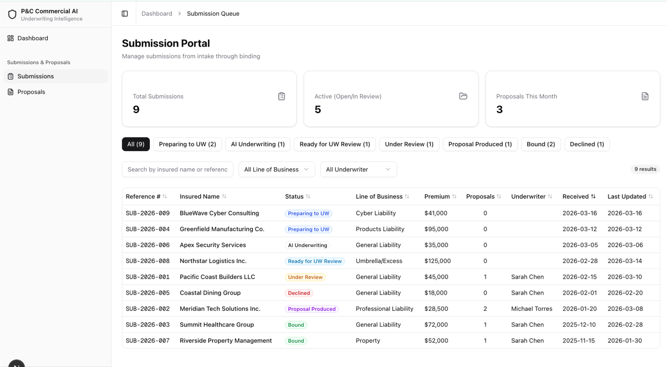

The interface models a seven-stage submission lifecycle that reflects an AI-first underwriting workflow:
Status | Label | Meaning
preparing_to_uw | Preparing to UW | Submission received; documents are being gathered and queued for AI processing. No underwriter is assigned yet.
ai_underwriting | AI Underwriting | The AI engine is actively analyzing documents, extracting structured data, running rating models, and flagging risk concerns. No underwriter is assigned yet.
ready_for_uw_review | Ready for UW Review | AI analysis is complete and the submission is queued for a human underwriter to pick up. No underwriter is assigned yet.
under_review | Under Review | An underwriter has claimed the submission and is actively reviewing AI outputs, loss runs, and supplemental information.
proposal_produced | Proposal Produced | One or more proposals (Good/Better/Best options) have been generated and are ready for broker presentation or internal approval.
bound | Bound | The broker has accepted a proposal and the policy has been bound. Terminal status.
declined | Declined | The submission was declined due to risk appetite, loss history, or other underwriting reasons. Terminal status.
Submissions in the first three statuses (Preparing to UW, AI Underwriting, Ready for UW Review) do not have an assigned underwriter. An underwriter is assigned when the submission transitions to Under Review.

Summary Stat Cards
Three KPI cards span the top of the page:
Card | Value
Total Submissions | Count of all submissions in the system
Active (Open / In Review) | Count of submissions in preparing_to_uw, ai_underwriting, ready_for_uw_review, or under_review
Proposals This Month | Count of proposals created in the current calendar month

Status Filter Tabs
A horizontal row of tabs appears below the stat cards. An All tab shows every submission; one tab per status shows only submissions matching that status. Each tab displays a count badge. Tabs are color-coded to match the status palette defined above.

Search and Filter Toolbar
Control | Behavior
Text search | Filters by insured name or reference number (case-insensitive substring match). Placeholder: “Search by insured name or reference…”
Line of Business dropdown | Filters by coverage line: General Liability, Professional Liability, Cyber Liability, Products Liability, Umbrella/Excess, Property
Underwriter dropdown | Filters by assigned underwriter name: Sarah Chen, Michael Torres
Clear Filters button | Resets all active filters, search text, and status tab to “All”
Result count | Displays “N results” reflecting the intersection of all active filters
All filters stack — selecting a status tab, typing a search term, and choosing a Line of Business dropdown value simultaneously narrows the result set to the intersection of all three criteria.

Submissions Table
Nine sortable columns:
Column | Data Field | Notes
Reference # | referenceNumber | Monospace font (e.g., SUB-2026-001)
Insured Name | insuredName | Primary identifier for the submission
Status | status | Color-coded badge using the status palette
Line of Business | lineOfBusiness | Coverage type (GL, PL, Cyber, etc.)
Premium | premiumIndication | Formatted as USD with no decimal places
Proposals | proposalCount | Integer count, centered
Underwriter | assignedUnderwriter | Blank for submissions in pre-review statuses
Received | receivedDate | YYYY-MM-DD format
Last Updated | lastUpdated | YYYY-MM-DD format
Sorting: Clicking any column header sorts ascending on that column; clicking the same header again toggles to descending. An arrow icon indicates the active sort column and direction. Default sort is Received date, newest first.
Row click: Clicking any row navigates to the submission detail page at /submissions/[id].
Empty state: When no submissions match the active filters, the table displays: “No submissions match the current filters.”

Interaction points
# | Interaction | Behavior
1 | Status tab click | Filters table to the selected status; clicking “All” removes the status filter
2 | Text search input | Live-filters table rows as the user types; matches against insured name and reference number
3 | Line of Business dropdown select | Filters table to submissions matching the selected coverage line
4 | Underwriter dropdown select | Filters table to submissions assigned to the selected underwriter
5 | Clear Filters click | Resets search text, dropdown selections, and status tab to “All”; table shows all submissions
6 | Column header click | Toggles sort direction (ascending/descending) on that column
7 | Table row click | Navigates to the submission detail page (/submissions/[id])

Key inputs

Input | Source | Description
Submission intake data | Broker / external system | Insured name, NAICS code, coverage line, effective/expiration dates, broker name, estimated premium. Populates the table row for each submission.
Status transitions | AI pipeline / underwriter | Automatic progression through AI stages (preparing_to_uw → ai_underwriting → ready_for_uw_review); manual transitions from under_review onward. Determines which status tab a submission appears under.
Underwriter assignment | System / manager | Assigned when a submission moves to under_review. Populates the Underwriter column and enables the Underwriter dropdown filter.
Proposal creation events | Underwriter (downstream) | Increments the Proposals column count and the Proposals This Month stat card.

Key outputs

Output | Consumer | Description
Filtered submission list | Underwriter | Prioritized, narrowed view of the submission pipeline based on status, coverage line, underwriter, and search terms
Summary statistics | Underwriter / management | At-a-glance KPIs: total volume, active count, and monthly proposal throughput
Status distribution | Underwriter | Per-status counts on the filter tabs reveal pipeline bottlenecks (e.g., many submissions stuck in Ready for UW Review)
Navigation to detail | Underwriter | Row click routes the user to the full submission workspace for in-depth review

Acceptance criteria

Status Lifecycle
- All seven statuses (preparing_to_uw through declined) render with correct labels, colors, and badge styling.
- Submissions in preparing_to_uw, ai_underwriting, and ready_for_uw_review display a blank Underwriter column.
- bound and declined are terminal statuses with no forward transitions.

Stat Cards
- Total Submissions displays the count of all submissions regardless of status.
- Active (Open / In Review) displays the count of submissions in preparing_to_uw, ai_underwriting, ready_for_uw_review, or under_review.
- Proposals This Month displays the count of proposals with a creation date in the current calendar month.
- All three counts update correctly when underlying data changes.

Status Filter Tabs
- The “All” tab is selected by default and shows every submission.
- Clicking an individual status tab filters the table to only submissions in that status.
- Each tab displays a count badge matching the number of submissions in that status.

Search and Filters
- Text search filters by insured name and reference number using case-insensitive substring matching.
- Line of Business dropdown filters the table to the selected coverage line.
- Underwriter dropdown filters the table to the selected underwriter.
- All filters (status tab, text search, Line of Business, Underwriter) stack — the result set is the intersection of all active criteria.
- Clear Filters resets search text, dropdown selections, and status tab to “All”.
- The result count label accurately reflects the number of visible rows.

Table
- All nine columns are present: Reference #, Insured Name, Status, Line of Business, Premium, Proposals, Underwriter, Received, Last Updated.
- All nine columns are sortable in both ascending and descending order.
- Default sort is Received date, descending (newest first).
- Premium values are formatted as USD with no decimal places.
- Clicking a row navigates to
- When no rows match the active filters, the empty state message “No submissions match the current filters.” is displayed.

Out of scope
- Role-based access control — All users see all submissions. Permission gating (e.g., restricting visibility by underwriter assignment) is deferred.
- Real-time updates / WebSocket push — Status changes and new submissions do not stream to other connected clients.
- Bulk actions — No multi-select or batch status transitions on the submissions list.
- Advanced search — No date-range filters, premium-range sliders, or saved/named filter presets.
- Submission creation — There is no “New Submission” intake form; submissions are assumed to arrive from an external broker portal or integration.
- Notifications and alerts — No email, Slack, or in-app notifications when a submission changes status.
- Export / print — No CSV export or print-optimized view of the submissions list.

Submission and proposal human in the loop review and modify user interface and data model (EPIC-60, HL-UNDERWRITE)

Description
Provide user interface and data model to store to enable review and modification of the submissions and policy proposal creation then send to a broker as a response. The Submission Detail page is the primary workspace for reviewing a single insurance submission. It is organized into four distinct sections: a Primary section that is always visible regardless of which tab is selected, and three tab panels — Overview, Loss Runs, and Structured Data — that the user switches between. Assume all fields are editable and come in via the document extraction step.
The page supports the full seven-status AI underwriting pipeline (preparing_to_uw through declined). Submissions in pre-review statuses display “Unassigned” for the underwriter.

Page Sections

Primary (Always Visible)
The Primary section remains on screen at all times, above the tab bar. It contains three sub-components stacked vertically.

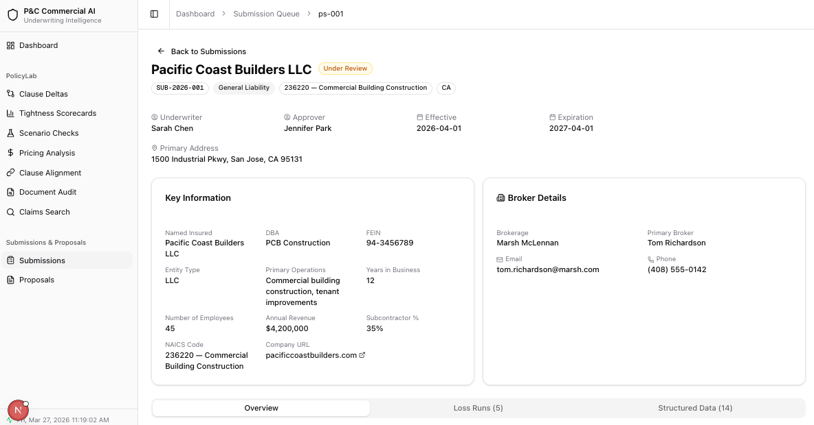

Displays the core identity and assignment information for the submission.
Element | Content
Back button | “Back to Submissions” — navigates to /submissions
Title | Insured name (e.g., “Pacific Coast Builders LLC”)
Status badge | Color-coded badge reflecting current submission status
Information badges | Reference number (monospace), Line of Business, NAICS code + description, State
Action buttons | “Change Status” (outline, conditional) and “Generate Proposal” (primary, conditional)

Assignment grid (up to 4 columns):
Field | Icon | Notes
Underwriter | UserCircle | Shows name or “Unassigned” for pre-review statuses
Approver | UserCircle | Only shown if an approver is assigned
Effective Date | Calendar | YYYY-MM-DD
Expiration Date | Calendar | YYYY-MM-DD
Primary Address (conditional): Shown below the grid with a MapPin icon if the submission has a primaryAddress value.

Key Information Card
A card displaying extracted structured fields from the Insured Information and Operations field groups, plus system-level fields.
Data | Source
Extracted fields | PortalStructuredField entries where fieldGroup is “Insured Information” or “Operations” (e.g., Named Insured, DBA, FEIN, Entity Type, Primary Operations, Years in Business, Number of Employees, Annual Revenue, Subcontractor %)
NAICS Code | submission.naicsCode — displayed as “code — description”
Company URL | submission.companyUrl — clickable external link opening in a new tab

Broker Details Card
A card displayed beside Key Information in a 2-column layout.
Field | Notes
Brokerage | Company name (e.g., “Marsh McLennan”)
Primary Broker | Contact person name
Email | Broker email address with Mail icon
Phone | Broker phone number with Phone icon

All broker fields except Brokerage are conditional — only displayed when present.

Overview Tab (Default)
A two-column layout (2/3 left, 1/3 right) containing the working content for the submission.

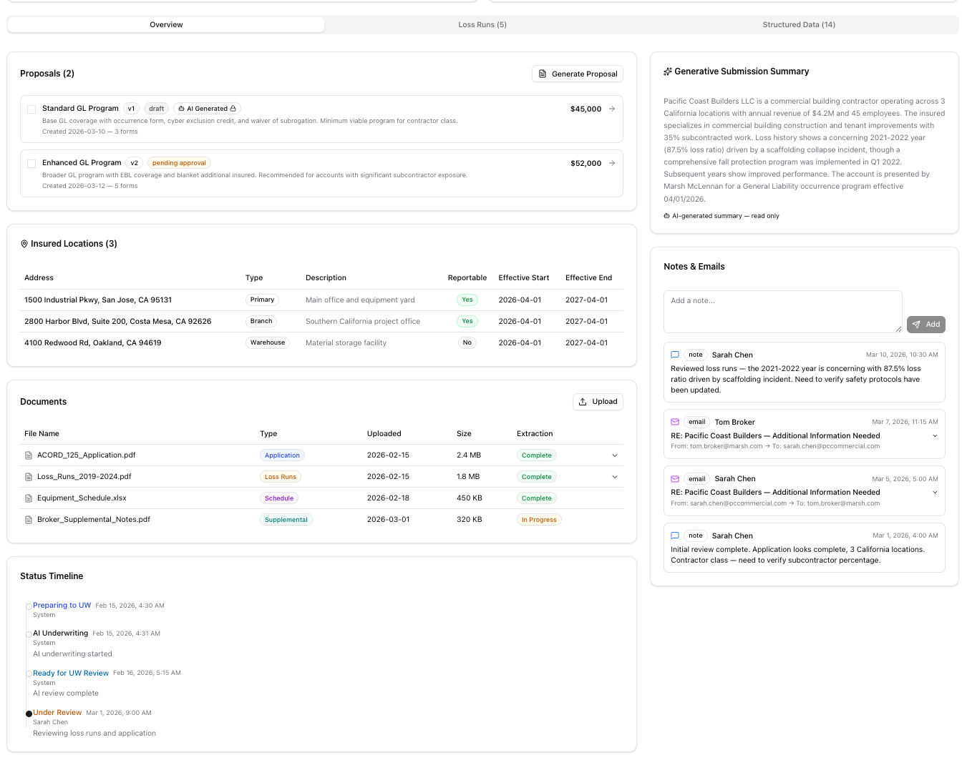

Left Column

Proposals Card
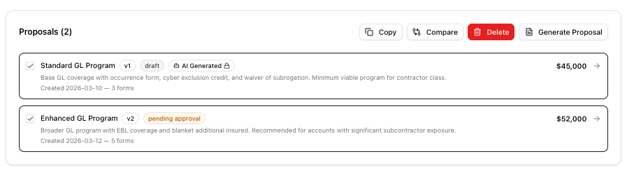
Displays all proposals linked to this submission with selection, action buttons, and navigation.
- Header: “Proposals (N)” with a “Generate Proposal” button.
- Checkboxes: Each proposal row has a checkbox on the left. Maximum of 2 can be selected at a time; additional checkboxes are disabled when 2 are checked.
- Action buttons (appear contextually when proposals are selected):
  - Copy — appears when 1+ selected; duplicates the selected proposal
  - Compare — appears when exactly 2 selected; opens a comparison view
  - Delete — appears when 1+ selected; hidden if all selected proposals are AI-generated (immutable)

- AI-generated badge: Proposals with aiGenerated: true display a violet “AI Generated” badge with Bot and Lock icons. These proposals cannot be deleted, only copied.
Each proposal row displays:
Element | Description
Checkbox | Selection control (max 2)
Label | Proposal name (e.g., “Standard GL Program”)
Version badge | “v1”, “v2”, etc.
Status badge | Color-coded: draft (zinc), pending_approval (amber), approved (green), declined (red)
AI badge | Violet badge with Bot + Lock icons (only for AI-generated proposals)
Description | 1–2 line description text (truncated with line-clamp)
Metadata line | “Created {date} — {N} forms”
Premium | Formatted as USD on the right side
Arrow | Navigation arrow; clicking the row navigates to proposal

Insured Locations Card
Shown when the submission has one or more insuredLocations. Displays a MapPin icon and count in the header. Each location is rendered as a bordered row with: - Address text - Type badge (e.g., “Primary”, “Branch”, “Warehouse”). Locations are displayed in a responsive 1–2 column grid.
This is the location schedule shared by all proposals and is the starting point for a schedule

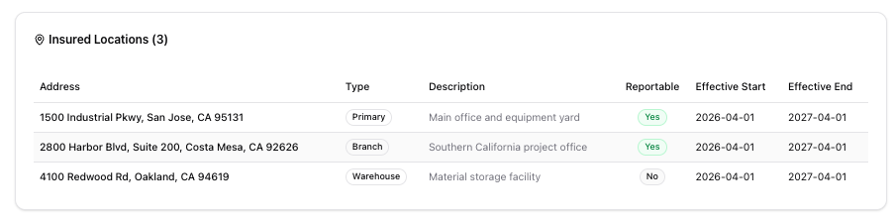

Documents Card
Manages uploaded documents with AI extraction status tracking. This reflects what is in the submission folders in ImageRight and any meta data related to the submission.
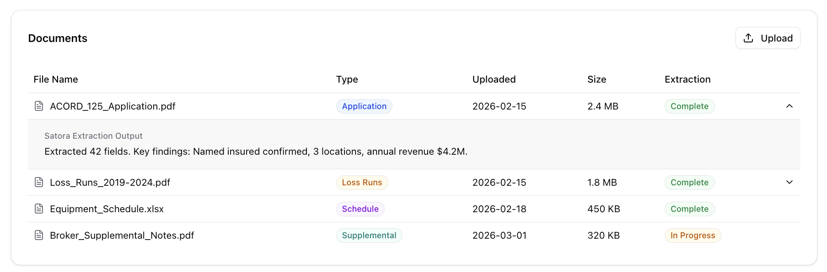
- Header: “Documents” title with an “Upload” button.
Documents table columns:
Column | Description
File Name | Document name with FileText icon
Type | Meta data from ImageRight — application, loss_runs, schedule, endorsement, supplemental, correspondence
Uploaded | Date in YYYY-MM-DD format
Size | File size (e.g., “2.4 MB”)
Extraction | Status badge — complete (green), in_progress (amber), failed (red), pending (zinc)
Expand | Chevron icon; only shown for documents with Satora extraction output
Expandable rows: Clicking a row with extraction output expands it to show the Satora extraction summary text (e.g., “Extracted 42 fields. Key findings: Named insured confirmed, 3 locations, annual revenue $4.2M.”).
Empty state: “No documents uploaded.”

Status Timeline Card
Vertical timeline showing chronological status progression.
Each entry displays: - Dot: Filled circle for the latest entry, hollow circle for prior entries - Status label: Color-coded text matching the status palette - Timestamp: Formatted as “Mar 10, 2026, 2:30 PM” - User: Who made the status change (or “System” for automated transitions) - Note (optional): Additional context for the transition
The timeline reads top-to-bottom with the most recent entry showing a filled primary-colored dot and earlier entries showing hollow dots connected by a vertical line.

Right Column

Generative Submission Summary Card
Shown when the submission has an AI-generated submissionSummary. Read-only.
- Header: Sparkles icon with “Generative Submission Summary” title
- Body: Multi-sentence AI-generated narrative summarizing the submission (insured profile, loss history highlights, broker, coverage requested)
- Footer: Bot icon with “AI-generated summary — read only” in violet text

Notes & Emails Card
Chronological feed of internal notes and email correspondence.
- Add Note section (top): Textarea (“Add a note…”) with Send button. Disabled when empty. Hidden when in readOnly mode.
- Feed: Sorted newest-first. Each entry shows:
  - Icon: Blue MessageSquare for notes, purple Mail for emails
  - Type badge: “note” or “email”
  - Author: Bold name
  - Timestamp: Right-aligned, formatted date/time
  - Content: For notes — plain text with whitespace preserved. For emails — collapsible section showing subject line, from/to addresses, and expandable body.
- Empty state: “No notes or emails yet.”

Loss Runs Tab
Displays historical loss data with summary calculations that are extracted and normalized by Cytora
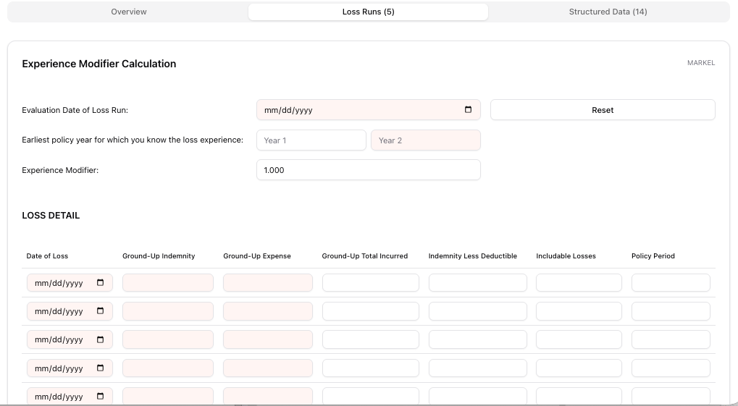

Card | Calculation
3-Year Weighted Avg Loss Ratio | totalIncurred / totalPremium for first 3 policy years
5-Year Weighted Avg Loss Ratio | totalIncurred / totalPremium for first 5 policy years
Loss History Table (8 columns):
Column | Format | Notes
Policy Year | Text | e.g., “2023-2024”
Carrier | Text | Insurance carrier name
Premium | USD | No decimal places
Claims | Integer | Claim count
Incurred | USD | Total incurred losses
Paid | USD | Paid amount
Reserves | USD | Outstanding reserves
Loss Ratio | Percentage | Color-coded: red (>60%), amber (>40%), green (<=40%)

Large Losses Section (conditional — only shown if large losses exist):
Column | Format
Policy Year | Text
Description | Loss description text
Amount | USD
Status | Badge — “open” (amber) or “closed” (zinc)
GL-specific variant: When the submission’s Line of Business is “General Liability”, the tab renders a specialized Experience Modifier component instead of the standard loss run table.
Empty state: “No loss run data available.”

Structured Data Tab
Displays AI-extracted fields organized by category with confidence scores and manual override capability. This will be finalized as the AI models and extraction are completed. This is purely for illustration.

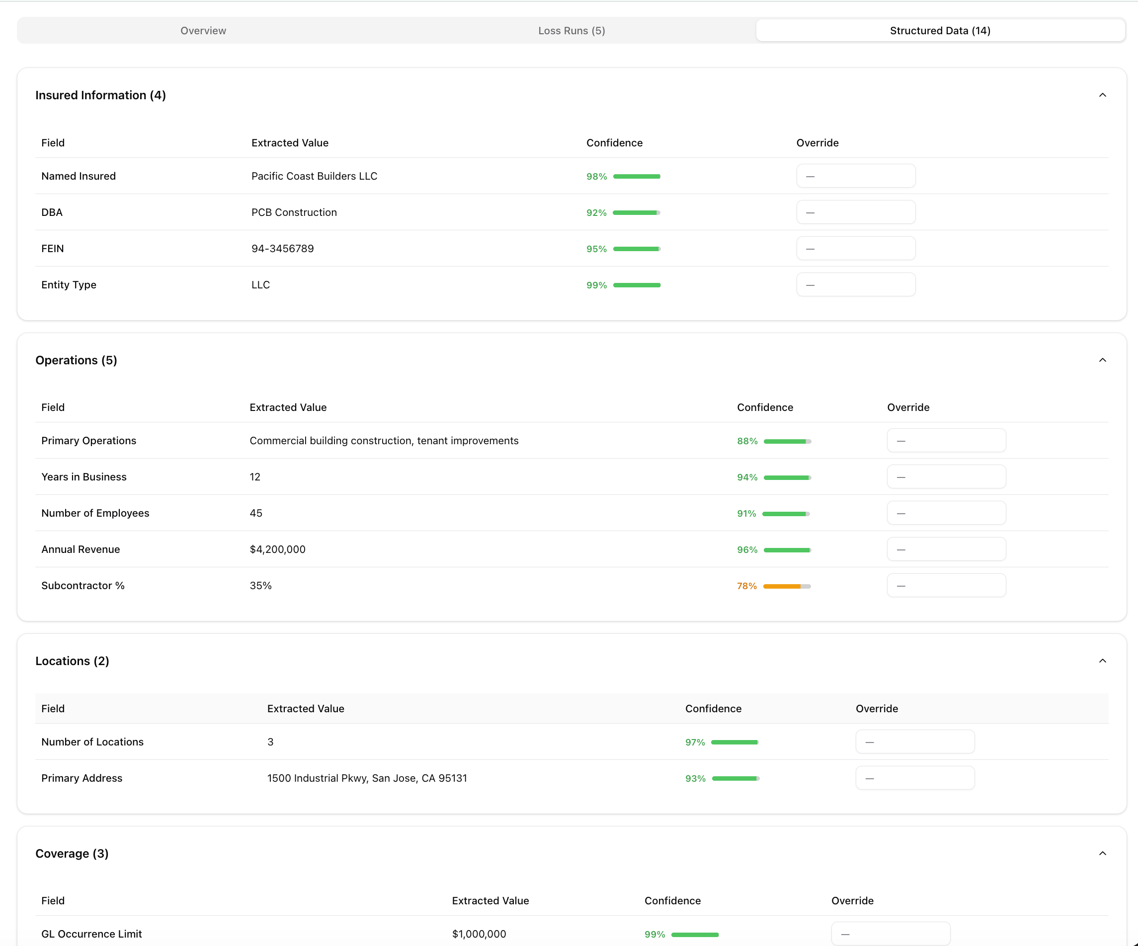

Field Groups (collapsible sections): - Groups are created dynamically from the fieldGroup property on each field - Default expanded groups: “Insured Information”, “Operations”, “Coverage”, “Locations” - Each group header shows: group name + field count (e.g., “Insured Information (5)”) - Clicking the header toggles expansion; ChevronDown icon rotates 180 degrees when open
Fields Table (within each group, 4 columns):
Column | Description
Field | Field name (e.g., “Named Insured”, “Annual Revenue”)
Extracted Value | Original AI-extracted value
Confidence | Visual confidence bar + percentage (e.g., 98%). Uses ConfidenceScore component
Override | Text input field for manual corrections. Shows amber Pencil icon when an override value exists. Placeholder: “—”
Override values are stored separately and do not replace the original extracted value — both are preserved.
Empty state: “No structured data available.”

Interaction points
# | Interaction | Section | Behavior
1 | Back button click | Primary — Header | Navigates to /submissions list page
2 | Change Status button | Primary — Header | Opens status transition dialog (conditional — only shown when handler provided)
3 | Generate Proposal button | Primary — Header / Overview — Proposals | Initiates AI or manual proposal creation workflow
4 | Company URL click | Primary — Key Information | Opens company website in a new browser tab
5 | Tab switch | Tab bar | Switches visible content between Overview, Loss Runs, and Structured Data
6 | Proposal checkbox toggle | Overview — Proposals | Selects/deselects a proposal (max 2); enables contextual action buttons
7 | Copy button | Overview — Proposals | Duplicates the selected proposal(s) as a new editable version
8 | Compare button | Overview — Proposals | Opens side-by-side comparison of 2 selected proposals
9 | Delete button | Overview — Proposals | Deletes selected proposals (hidden for AI-generated proposals)
10 | Proposal row click | Overview — Proposals | Navigates to proposal detail page at /submissions/[id]/proposals/[proposalId]
11 | Upload button | Overview — Documents | Creates a new pending document entry
12 | Document row expand | Overview — Documents | Expands to show Satora AI extraction output (only for documents with extraction results)
13 | Add Note submit | Overview — Notes & Emails | Appends a new internal note to the feed with current timestamp
14 | Email entry expand | Overview — Notes & Emails | Expands to reveal email subject, from/to addresses, and full body content
15 | Structured field override | Structured Data | Enters a manual correction value for an AI-extracted field
16 | Group expand/collapse | Structured Data | Toggles visibility of a field group’s contents

Key inputs
Input | Source | Description
Submission intake data | Broker / external system | Insured name, NAICS, coverage line, effective/expiration dates, broker details, primary address, company URL, insured locations
Uploaded documents | Broker / underwriter | PDFs (applications, loss runs, supplements) uploaded via the Documents card; trigger AI extraction pipeline
AI extraction outputs | Satora extraction engine | Structured fields with field group, field name, extracted value, and confidence score per document
AI submission summary | AI pipeline | Narrative summary generated from submission data and extracted fields; displayed read-only in the Generative Submission Summary card
AI-generated proposals | AI pipeline | Proposals with aiGenerated: true; immutable, can only be copied to create editable versions
Underwriter overrides | Human underwriter | Manual corrections to extracted structured fields via the Override column in the Structured Data tab
Internal notes | Underwriter | Free-text notes added via the Notes & Emails card
Email correspondence | Email integration | Inbound/outbound emails with subject, from/to, and body displayed in the Notes & Emails feed
Loss run data | Broker / carrier | Policy-year-level loss history including premium, claims, incurred, paid, reserves, and large losses
Status transitions | AI pipeline / underwriter | Automatic progression through AI stages; manual transitions from Under Review onward; recorded in Status Timeline

Key outputs

Output | Consumer | Description
Submission dossier | Underwriter | Complete view of the submission: insured profile, broker info, locations, documents, loss history, AI extractions, and status timeline — all accessible without leaving the page
Generative summary | Underwriter / management | AI-generated narrative summarizing the submission for quick triage and decision-making
Proposal list with selection | Underwriter | Actionable list of proposals with checkboxes enabling copy, compare (2 max), and delete operations
Structured data with overrides | Downstream systems / proposal generation | AI-extracted fields with human corrections; both original and override values preserved for audit
Loss ratio analysis | Underwriter | Weighted average loss ratios (3-year and 5-year) with color-coded thresholds for quick risk assessment
Status timeline | Audit trail | Chronological record of every status transition with actor, timestamp, and notes
Document extraction summaries | Underwriter | Satora AI extraction output providing at-a-glance summaries of document contents
Notes & email thread | Underwriter / broker | Complete correspondence and internal commentary history for the submission

Acceptance criteria

Primary Section (Always Visible)
- The header, Key Information card, and Broker Details card remain visible when switching between Overview, Loss Runs, and Structured Data tabs.
- Insured name and status badge display correctly; status badge uses the correct color from the seven-status palette.
- Reference number, Line of Business, NAICS code + description, and State appear as information badges below the title.
- Underwriter displays “Unassigned” for submissions in preparing_to_uw, ai_underwriting, or ready_for_uw_review.
- Approver field is only displayed when an approver is assigned.
- Primary Address displays with MapPin icon when present; hidden when absent.
- Key Information card shows all extracted fields from “Insured Information” and “Operations” groups, plus NAICS Code and Company URL.
- Company URL opens in a new tab when clicked.
- Override values in Key Information take precedence over extracted values.
- Broker Details card shows Brokerage, Primary Broker, Email, and Phone; optional fields are hidden when empty.

Overview Tab
- Proposals card displays correct count and lists all proposals for this submission.
- Each proposal row shows label, version, status badge, description, creation date, form count, and premium.
- AI-generated proposals display a violet “AI Generated” badge with Bot and Lock icons.
- Checkboxes allow selecting up to 2 proposals; checkboxes are disabled when 2 are already selected.
- Copy button appears when 1+ proposals are selected.
- Compare button appears only when exactly 2 proposals are selected.
- Delete button appears when 1+ non-AI proposals are selected; hidden if all selected proposals are AI-generated.
- Clicking a proposal row navigates to the proposal detail page.
- Insured Locations card displays all locations with address and type badge; hidden when no locations exist.
- Documents card lists all documents with file name, type badge, upload date, size, and extraction status badge.
- Upload button creates a new document entry with “pending” extraction status.
- Document rows with Cytora output expand to show extraction summary; rows without output have no expand control.
- Status Timeline displays all entries chronologically with correct status colors, timestamps, actors, and notes.
- Latest timeline entry has a filled dot; prior entries have hollow dots.
- Generative Submission Summary card displays the AI summary text when present; hidden when absent.
- Generative Summary is read-only with no edit controls.
- Notes & Emails card sorts entries newest-first.
- Adding a note via the textarea appends it to the feed with current timestamp and “Current User” author.
- Email entries are expandable to show subject, from/to, and full body.

Loss Runs Tab
- 3-Year and 5-Year weighted average loss ratio cards display correct calculated values.
- Loss History table displays all columns: Policy Year, Carrier, Premium, Claims, Incurred, Paid, Reserves, Loss Ratio.
- Loss Ratio values are color-coded: red (>60%), amber (>40%), green (<=40%).
- Large Losses section appears only when large losses exist for the submission.
- Large loss status badges use correct colors: “open” (amber), “closed” (zinc).
- GL submissions render the specialized Experience Modifier component instead of the standard loss run table.
- Empty state displays “No loss run data available.” when no loss runs exist.

Structured Data Tab
- Fields are grouped by fieldGroup and displayed in collapsible sections.
- Default expanded groups: “Insured Information”, “Operations”, “Coverage”, “Locations”.
- Each group header shows group name and field count; clicking toggles expansion.
- Confidence column displays a visual bar and percentage via the ConfidenceScore component.
- Override input accepts text input and shows an amber Pencil icon when a value is entered.
- Override values are stored separately and do not replace extracted values.
- Empty state displays “No structured data available.” when no fields exist.

Out of scope
- Document upload action: Creates a new document entry with type “supplemental” and extraction status “pending”. Plan for future phase
- Sending email via the application: Notes and email will only view emails not send emails. New emails will be discovered via ImageRight integration.
- Proposal detail page — The proposal detail view (/submissions/[id]/proposals/[proposalId]) with its Rates, Notes, and Forms tabs is covered by a separate epic.
- Proposal comparison view — The Compare button stubs navigation to a future comparison page; the comparison UI itself is not part of this epic.
- Role-based access control — All users can view and edit all submissions. Permission gating by role (underwriter, approver, admin) is deferred.
- Real-time collaboration — Multiple users editing the same submission concurrently (e.g., overrides, notes) is not supported.
- Notifications — No alerts when documents finish extraction, proposals are generated, or status changes occur.
- Print / export — No print-optimized view or PDF export of the submission detail page.

Proposal detail interface to review, price, and finalize individual proposals (EPIC-61, HL-UNDERWRITE)

Description
The Proposal Detail page (/submissions/[id]/proposals/[proposalId]) is the primary workspace for building, reviewing, and pricing a single insurance proposal within a submission. It provides a comprehensive pricing worksheet, forms management, and location scheduling interface.
The page operates in two distinct modes based on how the proposal was created:
Editable mode — The default for human-created proposals. All fields, limits, rates, forms, and locations can be modified. Search bars, add/remove buttons, and input fields are all visible and functional.
Read-only mode — Applied automatically to AI-generated proposals (aiGenerated: true). A violet banner with Bot and Lock icons indicates immutability. All input fields render as static text, all add/remove/edit controls are hidden, and all checkboxes are disabled. The user must copy the proposal to create an editable version.

Page Sections

Primary (Always Visible)
The Primary section remains on screen above the tab bar at all times. It contains navigation, an optional AI immutable banner, the proposal header, and a summary + notes area.

Back Link
A ghost button with ArrowLeft icon navigating back to the parent submission detail page (/submissions/[id]). Label reads "Back to {Insured Name}".

AI Immutable Banner (Read-Only Proposals Only)
Displayed only when the proposal has aiGenerated: true. A violet-bordered banner with Bot and Lock icons, title "AI-Generated Proposal — Read Only", and description: "This proposal was generated by AI and cannot be edited. Copy it to create an editable version."

Proposal Header
Displays the proposal label, version badge (v1, v2, etc.), status badge (draft/pending_approval/approved/declined with color coding), AI Generated badge (violet, for AI proposals only), context line showing insured name, reference number, and submission status badge, and total premium formatted as USD.
Action buttons (right-aligned):
Button | Condition | Behavior
Copy to Edit / New Version | Always shown. Label is "Copy to Edit" for AI proposals, "New Version" otherwise | Duplicates the proposal as a new editable version
Export Proposal PDF | Always shown | Generates and downloads a PDF export of the proposal
Approve | Only shown when !readOnly && status === "pending_approval" | Approves the proposal
Decline | Only shown when !readOnly && status === "pending_approval" | Declines the proposal

Generative Proposal Summary & Notes
A two-column layout (50/50 on large screens) displayed below the header and above the tab bar.
Generative Proposal Summary Card (left): Sparkles icon header with Regenerate button (RefreshCw icon). Displays a multi-sentence AI-generated narrative describing the proposal's coverage structure, key endorsements, pricing methodology, and total premium. Footer: Bot icon + "AI-generated summary — regenerate to reflect latest changes" (violet).
Proposal Notes Card (right): Textarea ("Add a note...") with Send button (disabled when empty). Scrollable feed (max 280px) sorted newest-first. Each entry shows MessageSquare icon for notes or Mail icon for emails, author name, timestamp, and content. Empty state: "No notes yet."

Tab Bar
Three tabs available: Rate & Pricing Worksheet (default, value: pricing), Forms (N) showing form count, and Proposal Location Schedule (N) showing location count.

Rate & Pricing Worksheet Tab
A two-column layout (2/3 left worksheets, 1/3 right sticky price summary). This is the core pricing workspace.

General Liability Card
Contains commission rate, coverage limits with enable/disable checkboxes, terrorism toggle, and defense within limits.
Commission Rate: In editable mode, a number input (0-100, step 0.5) with % suffix. In read-only mode, static percentage text.
Coverage Limits (checkbox-controlled list):
Coverage | Default | Limits
Coverage Limits | Enabled | Per Occurrence ($1,000,000), General Aggregate ($2,000,000)
Products / Completed Operations Aggregate | Enabled | Limit ($2,000,000)
Personal / Advertising Injury | Enabled | Limit ($1,000,000)
Damage to Premises Rented to You | Enabled | Limit ($100,000)
Medical Expense | Disabled | Limit ($5,000)
Per Location/Project Aggregate Cap | Disabled | Limit ($2,000,000)
Aggregate Reinstatements (per policy period) | Disabled | Limit ($0)

Editable mode: Checkboxes toggle coverage on/off. Limit amounts are editable number inputs. Disabled coverages are dimmed (opacity-50). Read-only mode: Checkboxes disabled, limits shown as static formatted currency.
Defense within Limits: Single checkbox, always unchecked by default. Terrorism: Checkbox toggles terrorism coverage. Rate % is editable (0-100, step 0.1). Terrorism Premium is calculated. Commission (bottom): Shows commission rate and calculated amount based on final premium.

Deductibles Card
DollarSign icon header with Add button (editable mode only). Table with columns: Enable checkbox, Type, Applies To, Amount, and Delete button (editable only). Default deductibles: Per Occurrence ($5,000 for BI & PD) and Products/Completed Ops ($5,000). In editable mode all fields are inputs; in read-only mode all are static text and add/delete buttons are hidden.

Fees Card
Receipt icon header with Add button (editable mode only). Table columns: Enable checkbox, Fee name, Description, Rate %, Flat Amount, and Calculated (always read-only, computed as premium * rate% + flat amount).
Fee | Rate % | Flat Amount | Default
Surplus Lines Tax | 3% | — | Enabled
Stamping Fee | 0.18% | — | Enabled
Policy Fee | — | $250 | Enabled
Filing Fee | — | $175 | Disabled

In editable mode, rate % and flat amount are number inputs; checkboxes are toggleable. In read-only mode, all values are static text and checkboxes are disabled. Footer row shows Total Fees.

Exposure Details Card
BarChart3 icon header with Edit button (editable mode only, toggles between Edit/Done). Data is grouped by location address. Each location group has a MapPin header and rate table.
Exposure table columns:
Column | View Mode | Edit Mode
Class Code | Static monospace text | Text input
Description | Static text | Text input
Territory | Static text | Text input
Exposure Base | Static text | Text input
Exposure | Static number | Number input
Base Rate | Static number | Number input (step 0.01)
Technical Rate | Calculated (always read-only) | Calculated (always read-only)
LCM | Static number | Number input (step 0.01)
Adjusted Premium | Static formatted currency | Number input (back-calculates LCM)
Delete | Hidden | Trash icon button

Add Location dropdown (edit mode): Shows available locations from the Proposal Location Schedule not yet in the exposure table. Add Row button adds a new class code row under a location. Location Subtotal row shows sum of adjusted premiums per location.
Auto-calculation: Changing Base Rate or Exposure recalculates Manual Premium (baseRate * exposure / 100) and Adjusted Premium (manualPremium * LCM). Changing LCM recalculates Adjusted Premium. Changing Adjusted Premium back-calculates LCM.

Priced Forms Card
Displays only forms with pricing adjustments (credits/debits). FileText icon header with form count. Search bar (editable mode only) for adding endorsements/exclusions from catalog.
Table columns:
Column | Description
Expand chevron | Toggles adjustment detail rows
Form Number | Monospace font (e.g., CG 21 06)
Edition | Date/version string
Form Name | Name with optional description subtitle
Type | Color-coded badge: Endorsement (purple), Exclusion (red)
Adj. (Net) | Net sum of adjustments. Green for credits, red for debits
Form Fill | ClipboardEdit button for forms with fill-in fields
Delete | Trash icon (editable mode only)

Expanded rows show: existing adjustments with description, type badge (debit=red, credit=green), amount, and X remove button (editable only). Plus an add adjustment row with description input, toggleable debit/credit badge, amount input, and Plus button (editable only). Form Fill-in rows: indigo-highlighted rows with label and input field (editable) or static text (read-only). Percentage fields show % suffix. Footer row: Total Form Adjustments (sum of net adjustments across all priced forms).

Loss Detail Card
ClipboardList icon header. Experience Modifier input at top (editable: number input 0-5 step 0.01; read-only: static text). Shows contextual label: Credit (<1), Debit (>1), Unity (=1).
Loss Detail Table (read-only, from submission data) columns: Date of Loss, Ground-Up Indemnity, Ground-Up Expense, Ground-Up Total Incurred, Indemnity Less Deductible, Includable Losses, Policy Period. Footer row: Total (column sums). Empty state: "No loss detail data available."

Price Summary Card (Right Column, Sticky)
A sticky card providing real-time pricing roll-up. Sections:
Exposure by Location: Each location's adjusted premium subtotal, followed by Indicated Premium total.
Premium Buildup: Form Adjustments, Technical Premium (pre-EMod), Experience Modifier, Technical Premium (post-EMod), Minimum Premium (50%).
Fees & Surcharges: Fees & Taxes total, Terrorism premium (if accepted).
Market Price: Bold large font — the all-in price. % Delta from Technical (green if below, red if above).
Commission: Rate and calculated amount. Summary counts: Rate Classes and Priced Forms.

Forms Tab
Full forms & endorsements schedule management. FileText icon header with total form count. Search bar (editable mode only) to search the forms catalog by number or name.
Table organized by category with collapsible headers (e.g., COMMON POLICY (4), GL COVERAGE (3), GL ENDORSEMENTS (14)). Columns: Expand chevron, Form Number (monospace), Edition, Form Name, Type badge (Policy=gray, Coverage=blue, Endorsement=purple, Exclusion=red, Notice=amber), Adj. (Net), Form Fill button, Delete button (editable only).
Expanded adjustment rows: Identical to Priced Forms card — shows existing adjustments with type badges and amounts, plus add row (editable only). Form Fill-in rows: Indigo-highlighted with label and input (editable) or static text (read-only). Percentage fields use number inputs with % suffix.
Search & Add (editable only): Search input filters the forms catalog. Dropdown shows form number, name, type badge, and Plus icon. Forms already in the schedule are excluded. Delete button removes a form from the schedule. Empty state: "No forms or endorsements attached to this submission."

Proposal Location Schedule Tab
Manages locations specific to this proposal. MapPin icon header with Add Location button (always shown). Locations are derived from the submission's schedule but can diverge independently.
Location table columns:
Column | Description
# | Row number (1-indexed)
Address | Full address text (bold)
Type | Outline badge (e.g., "Primary", "Branch") — hidden when empty
Description | Description text or "—"
Reportable | Badge — green "Yes" or zinc "No"
Effective Start | Date or "—"
Effective End | Date or "—"
Delete | Trash icon — removes from proposal schedule only

Add Location Form (expandable): Fields for Address (required), Type, Description, Reportable (checkbox, default checked), Effective Start (date), Effective End (date). Add to Schedule button disabled until address entered. Cancel closes form.
Footer note: "Adding a location adds it to both this proposal and the submission schedule. Removing only removes it from this proposal." Empty state: "No locations on this proposal. Click 'Add Location' to add one."

Read-Only vs Editable Mode Summary
The readOnly flag is set to true when proposal.aiGenerated === true. Key differences:
Component | Editable Mode | Read-Only Mode
AI Banner | Hidden | Violet banner with Bot + Lock icons
Copy button label | "New Version" | "Copy to Edit"
Approve/Decline buttons | Shown (if pending_approval) | Hidden
Coverage checkboxes | Toggleable | Disabled
Coverage limit inputs | Number inputs | Static currency text
Commission/terrorism rate | Number inputs | Static percentage text
Deductible fields | Text/number inputs with Add/Delete | Static text, no Add/Delete
Fee rate %/flat amount | Number inputs with Add button | Static text, no Add
Exposure Edit button | Shown | Hidden
Experience Modifier | Number input | Static text
Forms search bar | Shown | Hidden
Forms delete buttons | Shown | Hidden
Form adjustment add/remove | Add row + X remove shown | Hidden
Form fill-in fields | Input fields | Static text
Priced Forms search/add/remove | Shown | Hidden

Interaction points

# | Interaction | Section | Behavior
1 | Back button click | Primary — Back Link | Navigates to /submissions/[id]
2 | Copy to Edit / New Version | Primary — Header | Creates a duplicate editable proposal
3 | Export Proposal PDF | Primary — Header | Generates and downloads a PDF using generateProposalPdf()
4 | Approve button | Primary — Header | Approves a pending proposal (conditional: !readOnly && pending_approval)
5 | Decline button | Primary — Header | Declines a pending proposal (conditional: !readOnly && pending_approval)
6 | Regenerate summary | Summary Card | Triggers AI regeneration of the proposal summary based on current state
7 | Add proposal note | Notes Card | Appends a timestamped note to the proposal notes feed
8 | Tab switch | Tab Bar | Switches between Rate & Pricing Worksheet, Forms, and Proposal Location Schedule
9 | Toggle coverage | GL Card | Enables/disables a coverage line and its limits
10 | Edit coverage limit | GL Card | Changes a coverage limit amount; reflected in Price Summary
11 | Edit commission rate | GL Card | Changes commission percentage; recalculates commission in Price Summary
12 | Toggle/edit terrorism | GL Card | Enables/disables terrorism; changes rate; updates terrorism premium
13 | Toggle/edit/add/remove deductible | Deductibles Card | Manages deductible schedule entries
14 | Toggle/edit/add fee | Fees Card | Manages fee schedule; totals update Price Summary
15 | Edit exposure (toggle edit mode) | Exposure Card | Enters edit mode; all fields become inputs with auto-recalculation
16 | Add location to exposure | Exposure Card | Selects from proposal locations to add exposure rows
17 | Add/remove exposure row | Exposure Card | Adds a class code row under a location; Trash removes
18 | Edit experience modifier | Loss Detail Card | Changes the experience modifier; affects Technical Premium
19 | Toggle/edit form fill-in | Forms Tab / Priced Forms | Expands fill-in fields and edits values (text or percentage)
20 | Add/remove form | Forms Tab | Searches catalog and adds a form; Trash removes from schedule
21 | Add/remove adjustment | Forms Tab / Priced Forms | Adds credit/debit to a form; X removes; totals update Price Summary
22 | Toggle debit/credit type | Forms Tab / Priced Forms | Clicks the type badge to toggle between debit and credit
23 | Add location | Location Schedule Tab | Opens add form; adds to both proposal and submission schedules
24 | Remove location | Location Schedule Tab | Removes from proposal schedule only (not submission)

Key inputs

Input | Source | Description
Proposal data | Mock data / API | Proposal label, version, status, total premium, AI-generated flag, creation date
Submission data | Mock data / API | Insured name, reference number, submission status, line of business, insured locations
Proposal rates | Mock data / API | Per-location class codes with base rates, exposure, LCM, and adjusted premiums
Proposal forms | Mock data / API | Form schedule with form numbers, editions, names, types, categories, adjustments, and fill-ins
Submission forms | Mock data / API | Full submission-level form inventory (used for PDF export)
Loss runs | Mock data / API | Policy-year-level loss history from the parent submission
Loss details | Mock data / API | Individual loss records with ground-up indemnity, expense, deductible calculations
Proposal notes | Mock data / API | Internal notes and email correspondence specific to this proposal
Coverage limits | User input | Configurable per-coverage limits, enable/disable toggles
Deductible schedule | User input | Configurable deductible types, amounts, and enable/disable
Fee schedule | User input | Configurable fee rates, flat amounts, and enable/disable
Commission rate | User input | Broker commission percentage
Terrorism settings | User input | Accepted flag and rate percentage
Experience modifier | User input | Loss experience modifier affecting technical premium

Key outputs

Output | Consumer | Description
Price Summary | Underwriter | Real-time calculation: indicated premium, form adjustments, technical premium, fees, terrorism, market price, delta from technical, and commission
Proposal PDF | Broker / underwriter | Downloadable PDF export including coverage summary, rates, forms, and pricing
Form schedule | Downstream systems | Complete list of forms with editions, types, adjustments (credits/debits), and fill-in values
Location schedule | Downstream systems | Proposal-specific location list that can diverge from the submission schedule
Proposal notes | Underwriter / team | Timestamped internal commentary specific to this proposal
AI summary | Underwriter / management | Regenerable narrative summary of the proposal's structure and pricing

Acceptance criteria

Primary Section (Always Visible)
Back button navigates to the parent submission detail page.
AI-generated proposals display the violet immutable banner with Bot and Lock icons.
Proposal header shows label, version badge, status badge, and AI badge (when applicable).
Context line shows insured name (bold), reference number, and submission status badge.
Total premium displays formatted as USD.
"Copy to Edit" is shown for AI proposals; "New Version" for human proposals.
Export Proposal PDF button generates and downloads a PDF.
Approve and Decline buttons are only shown for non-AI proposals in pending_approval status.
Generative Proposal Summary card displays the AI summary with Sparkles icon and Regenerate button.
Regenerate button triggers summary refresh with spinning icon animation.
Notes card allows adding notes and displays them newest-first in a scrollable feed.

Rate & Pricing Worksheet Tab
Page renders in 2/3 left + 1/3 right sticky layout.
GL card displays all 7 coverage lines with correct default enable/disable states.
Coverage checkboxes toggle limits visibility; disabled coverages are dimmed.
Limit inputs accept numeric values and update Price Summary in real time.
Commission rate input updates the commission calculation.
Terrorism checkbox controls terrorism section visibility; rate input updates premium calculation.
Defense within Limits checkbox is present and unchecked by default.
Deductibles table shows enable checkbox, type, applies to, amount, and delete controls.
Add button creates new empty deductible row (editable mode only).
Fees table shows enable checkbox, name, description, rate %, flat amount, and calculated total.
Fee calculated column computes (premium * rate%) + flat amount.
Total Fees row sums all enabled fee calculated amounts.
Exposure Details groups rates by location with MapPin headers.
Edit button toggles all exposure fields to editable inputs.
Add Location dropdown shows available locations from proposal schedule.
Add Row button adds a new class code row under a location.
Auto-calculation: changing base rate or exposure recalculates manual and adjusted premium.
Auto-calculation: changing LCM recalculates adjusted premium.
Auto-calculation: changing adjusted premium back-calculates LCM.
Location Subtotal row shows sum of adjusted premiums per location.
Priced Forms card shows only forms with adjustments.
Form adjustments expand to show credit/debit detail rows.
Add adjustment row allows entering description, toggling debit/credit, entering amount.
Total Form Adjustments row displays the net sum.
Loss Detail table displays all individual loss records with column totals.
Experience Modifier input shows contextual label (Credit/Debit/Unity).
Price Summary sticky card updates in real time as worksheet values change.
Price Summary shows: Exposure by Location, Indicated Premium, Form Adjustments, Technical Premium, Minimum Premium, Fees & Taxes, Terrorism, Market Price, % Delta from Technical, Commission.

Forms Tab
Forms table is organized by category with collapsible category headers.
Category headers show name (uppercase) and count.
Each form row displays form number, edition, name, type badge, net adjustment, form fill button, and delete button.
Clicking a form row expands to show adjustments.
Existing adjustments display description, type badge (debit/credit), amount, and remove button.
Add adjustment row provides description input, debit/credit toggle, amount input, and add button (editable only).
Form fill-in button toggles indigo-highlighted fill-in rows.
Fill-in fields render as inputs (editable) or static text (read-only).
Percentage fill-ins use number inputs with % suffix.
Search bar filters the forms catalog and allows adding new forms (editable only).
Delete button removes a form from the schedule (editable only).
All editing controls are hidden in read-only mode.

Proposal Location Schedule Tab
Location table displays all proposal locations with row number, address, type badge, description, reportable badge, effective dates, and delete button.
Add Location button toggles the add location form.
Add location form has fields for address (required), type, description, reportable checkbox, effective start, and effective end.
"Add to Schedule" button is disabled until address is entered.
Adding a location adds it to both the proposal and submission schedules.
Removing a location removes it from the proposal schedule only.
Footer note explains the add/remove behavior difference.
Empty state displays when no locations exist.

Read-Only Mode (AI-Generated Proposals)
All input fields render as static text.
All add/remove/delete buttons are hidden.
All checkboxes are disabled.
Search bars are hidden.
The AI immutable banner is displayed.
"Copy to Edit" button is shown instead of "New Version".
Approve and Decline buttons are hidden regardless of status.

Out of scope
Proposal comparison view — The side-by-side comparison of two proposals is a separate epic.
Backend API integration — The current implementation uses client-side mock data. REST/GraphQL endpoints for proposals, rates, forms, and notes are a separate epic.
AI proposal generation — The pipeline that produces AI-generated proposals is out of scope.
AI summary regeneration — The Regenerate button is a stub. The actual AI endpoint is not implemented.
Approval workflow logic — The Approve and Decline buttons are stubs. Business rules governing approval chains, signatures, and notifications are deferred.
Role-based access control — All users can view and edit all proposals. Permission gating by role is deferred.
Version history — Tracking the full version history of a proposal across copies and edits is not implemented.
Real-time collaboration — Multiple users editing the same proposal concurrently is not supported.
Form catalog management — The forms catalog is static mock data. CRUD operations on the catalog itself are out of scope.
Location geocoding — Address validation and geocoding for proposal locations is not implemented.
Audit logging — Field-level edit history and audit trails beyond notes are not included.

Bind and issue policy with E2 integration (EPIC-70,BIND-ISSUE)

Description

Finalize the collection of subjectivities and all steps necessary to bind and issue the policy. Send the selected proposal to e2 to start the bind and issue process.

Interaction points

TBD

Key inputs

TBD

Key outputs

TBD

Acceptance criteria

TBD

Out of scope

TBD

Rating and pricing integration (EPIC-80, UW-SUPPORT)

Description

TBD

Interaction points

TBD

Key inputs

TBD

Key outputs

TBD

Acceptance criteria

TBD

Out of scope

TBD

TITLE (EPIC-90,UW-SUPPORT)

Description

TBD

Interaction points

TBD

Key inputs

TBD

Key outputs

TBD

Acceptance criteria

TBD

Out of scope

TBD

TITLE (EPIC-100, ,UW-SUPPORT)

Description

TBD

Interaction points

TBD

Key inputs

TBD

Key outputs

TBD

Acceptance criteria

TBD

Out of scope

TBD

TITLE (EPIC-110,ALL-STAGES)

Description

TBD

Interaction points

TBD

Key inputs

TBD

Key outputs

TBD

Acceptance criteria

TBD

Out of scope

TBD

TITLE (EPIC-120,ALL-STAGES

Description

TBD

Interaction points

TBD

Key inputs

TBD

Key outputs

TBD

Acceptance criteria

TBD

Out of scope

TBD

TITLE (EPIC-130,ALL-STAGES

Description

TBD

Interaction points

TBD

Key inputs

TBD

Key outputs

TBD

Acceptance criteria

TBD

Out of scope

TBD

TITLE (EPIC-140,ALL-STAGES)

Description

TBD

Interaction points

TBD

Key inputs

TBD

Key outputs

TBD

Acceptance criteria

TBD

Out of scope

TBD

TITLE (EPIC-150,ALL-STAGES

Description

TBD

Interaction points

TBD

Key inputs

TBD

Key outputs

TBD

Acceptance criteria

TBD

Out of scope

TBD

TITLE (EPIC-160,ALL-STAGES

Description

TBD

Interaction points

TBD

Key inputs

TBD

Key outputs

TBD

Acceptance criteria

TBD

Out of scope

TBD

